CRIMINAL LAW PAPER · ISLAMABAD HIGH COURT · CIVIL JUDGE-CUM-MAGISTRATE EXAMINATION 2026
Topic 4 · The Hudood Ordinances 1979
Hadd and ta'zir · Offence of Zina (Enforcement of Hudood) Ordinance · Offence of Qazf (Enforcement of Hadd) Ordinance · Offences against Property (Enforcement of Hudood) Ordinance — theft liable to hadd, hirz, nisab, haraabah · Prohibition (Enforcement of Hadd) Order · Execution of the Punishment of Whipping Ordinance · the Protection of Women (Criminal Laws Amendment) Act 2006
Knowledge Base — every concept in simple words, with rationale, cases, illustrations and maxims

Prepared for: Ihtisham Ul Haq (Roll No. 999)
Paper: Criminal Law (100 marks, 3 hours) — Pakistan Penal Code 1860, Code of Criminal Procedure 1898, Hudood Ordinances
This volume: Topic 4 of 4 — Hudood Ordinances
Companion volumes: Topic 1 — PPC: general principles · Topic 2 — PPC: specific offences (rape, fornication, theft) · Topic 3 — Code of Criminal Procedure (ss. 156B, 203A, 203C)
Text of the law used: Official texts (pakistancode.gov.pk) of Ordinances VI, VII, VIII and IX of 1979 and President's Order 4 of 1979, as amended by the Protection of Women (Criminal Laws Amendment) Act 2006 (Act VI of 2006)
Note on the syllabus: Bare Acts may be consulted in the examination for every subject except Muhammadan law, the Hudood Ordinances, Islamic jurisprudence and pleadings — so this topic must be learnt by heart

Contents
How to use this knowledge base 4
What Topic 4 covers 4
How the exam asks this topic 4
Chapter 1 · Foundations 5
1.1 Hadd and ta'zir 5
1.2 Tazkiyah-al-shuhood 5
1.3 The 1979 laws 5
1.4 The Protection of Women (Criminal Laws Amendment) Act 2006 5
Chapter 2 · The Offence of Zina (Enforcement of Hudood) Ordinance 1979 7
2.1 Definitions — s. 2 7
2.2 Zina — s. 4 7
2.3 Zina liable to hadd — s. 5 7
2.4 No conversion — s. 5A (2006) 7
2.5 Proof of zina liable to hadd — s. 8 7
2.6 Cases in which hadd shall not be enforced — s. 9 7
2.7 Execution of stoning — s. 17 8
2.8 Procedure — ss. 20, 21; CrPC 8
Chapter 3 · The Offence of Qazf (Enforcement of Hadd) Ordinance 1979 9
3.1 Qazf — s. 3 9
3.2 Qazf liable to hadd — s. 5 9
3.3 Proof — s. 6 9
3.4 Punishment — s. 7 9
3.5 Who can complain — s. 8 9
3.6 Hadd not imposed or enforced — s. 9 10
3.7 Lian — s. 14 10
3.8 Procedure — ss. 17, 18 10
Chapter 4 · The Offences against Property (Enforcement of Hudood) Ordinance 1979 — KPHC 2026 11
4.1 Definitions — s. 2 11
4.2 The concept of hirz (KPHC 2026) 11
4.3 Theft liable to hadd — s. 5 12
4.4 Nisab — s. 6 13
4.5 Proof — s. 7 (KPHC 2026) 13
4.6 Several offenders — s. 8 13
4.7 Punishment — s. 9 13
4.8 The process of implementation (KPHC 2026) 14
4.9 Cases in which hadd shall not be imposed — s. 10 15
4.10 Theft liable to ta'zir — ss. 13, 14 15
4.11 Haraabah — ss. 15 to 20 15
4.12 Other provisions 15
Chapter 5 · The Prohibition (Enforcement of Hadd) Order 1979 17
5.1 Definitions — Art. 2 17
5.2 Offences and punishments 17
5.3 Drinking, proof and arrest 17
Chapter 6 · The Execution of the Punishment of Whipping Ordinance 1979 19
Chapter 7 · Comparisons, maxims and last-night revision 20
7.1 The five hadd offences side by side 20
7.2 Ikrah, iztirar and the PPC's ikrah 20
7.3 Maxims 20
7.4 The 25 points of Topic 4 22
zzTOCENDzz

How to use this knowledge base

What Topic 4 covers
- Foundations — hadd and ta'zir, the Islamic standard of proof, the 1979 laws and the 2006 reforms, and the Federal Shariat Court's appellate jurisdiction.
- The Zina Ordinance — zina, zina liable to hadd, muhsan, proof by confession or four witnesses, cases where hadd is not enforced, and the complaint procedure (CrPC s. 203A).
- The Qazf Ordinance — qazf, qazf liable to hadd, proof, punishment (80 stripes), who may complain, and lian.
- The Offences against Property Ordinance — theft liable to hadd, hirz, nisab, proof, punishment and its implementation, exemptions, haraabah, rassagiri (KPHC 2026).
- The Prohibition Order — intoxicants, drinking liable to hadd and to ta'zir, proof, arrest, confiscation.
- The Whipping Ordinance — the whip and the mode of execution.
ISLAMABAD-SPECIFIC LAW · Why the Hudood laws apply in the ICT
All five laws "extend to the whole of Pakistan" (s. 1 of each) and were applied to the federal capital from their commencement on 12 Rabi-ul-Awwal 1399 AH (10 February 1979). Trials of hadd offences are held by the Court of Session, not by a s. 30 Magistrate, ordinarily at the tehsil headquarters; appeals lie to the Federal Shariat Court (Art. 203DD of the Constitution and the proviso to the relevant section of each Ordinance). The presiding officer must be a Muslim (unless the accused is non-Muslim).

How the exam asks this topic
Paper | What it asked
KP High Court, Criminal Law, 2026 | Theft liable to hadd, the requirements of its proof, and the process of its implementation; the concept of hirz in the Offences against Property Ordinance
LHC Civil Judge, Criminal Law, 2023 | Ikrah-e-tam / ikrah-e-naqis (compare ikrah and iztirar in the Hudood laws)
LHC ASJ, Criminal Law-I, 2025 | Compare ta'zir theft and dacoity under the PPC with haraabah (background)

Chapter 1 · Foundations

1.1 Hadd and ta'zir
Point | Hadd (plural hudood) | Ta'zir
Meaning | "Punishment ordained by the Holy Quran or Sunnah" (s. 2 of each Ordinance) | "Any punishment other than hadd" (s. 2)
Fixed? | Fixed in kind and quantity — no court, ruler or victim can increase, reduce, pardon or compound it | Discretionary — the State fixes it and the court chooses within limits
Proof | Strict: confession before the court, or a fixed number of Muslim adult male witnesses of proven integrity (tazkiyah-al-shuhood) | Ordinary evidence (Qanun-e-Shahadat 1984)
Doubt | The slightest doubt (shubha) defeats hadd | Benefit of reasonable doubt
Examples | Zina (stoning / 100 stripes), qazf (80 stripes), theft (amputation), haraabah, drinking (80 stripes) | Fornication (s. 496B PPC), theft under the PPC, drinking liable to ta'zir

LEGAL MAXIM · Idra'u al-hudood bi al-shubuhat
"Avert the hudood by doubts." Because hadd is severe and fixed, any doubt — in the evidence, the circumstances or the law — takes the case out of hadd; the offender may still be punished with ta'zir on ordinary evidence.

1.2 Tazkiyah-al-shuhood
"The mode of inquiry adopted by a Court to satisfy itself as to the credibility of a witness" — that the witnesses are truthful persons who abstain from major sins (kabair). The court inquires, openly or secretly, into the character of the witnesses (from people who know them) before accepting their evidence for hadd. If the accused is a non-Muslim, the witnesses may be non-Muslims.

1.3 The 1979 laws
- Offences against Property (Enforcement of Hudood) Ordinance — Ordinance VI of 1979.
- Offence of Zina (Enforcement of Hudood) Ordinance — Ordinance VII of 1979.
- Offence of Qazf (Enforcement of Hadd) Ordinance — Ordinance VIII of 1979.
- Execution of the Punishment of Whipping Ordinance — Ordinance IX of 1979.
- Prohibition (Enforcement of Hadd) Order — President's Order 4 of 1979.

1.4 The Protection of Women (Criminal Laws Amendment) Act 2006
The 2006 Act (Act VI of 2006) reshaped the Zina and Qazf Ordinances:
- Rape (zina-bil-jabr) was removed from the Zina Ordinance and placed in the PPC (ss. 375–376 — Topic 2), so that a rape victim who cannot produce four witnesses is no longer exposed to prosecution for zina.
- Ta'zir forms of zina were removed; consensual sex outside marriage proved by ordinary evidence became fornication (s. 496B PPC) — with false accusation of fornication punishable (s. 496C).
- Zina and fornication cases can begin only on a complaint in court (CrPC ss. 203A, 203C) — the police cannot register them; a zina complaint requires the complainant and four eye-witnesses to be examined on oath at the very outset.
- No conversion — a zina complaint or a rape allegation can never be converted into fornication, and vice versa (Zina Ordinance s. 5A).
- A woman accused of zina is investigated only by an officer not below SP and not arrested without the court's permission (CrPC s. 156B).
- Qazf — the ta'zir provisions were omitted; where a zina complaint fails, the court may convict the complainant of qazf without further proof (Qazf s. 6(2)); false accusation in other forms falls under defamation (PPC).
- Lian was added as a ground for dissolution of marriage — DMMA s. 2(viia) (Civil Law-II, Topic 1).

Chapter 2 · The Offence of Zina (Enforcement of Hudood) Ordinance 1979

2.1 Definitions — s. 2
- Adult — a male of 18, a female of 16, or one who has attained puberty.
- Confession — "notwithstanding any judgment of any court to the contrary, an oral statement, explicitly admitting the commission of the offence of zina, voluntarily made by the accused before a Court of Session having jurisdiction, or on receipt of a summons under s. 203A CrPC" (2006).
- Hadd — punishment ordained by the Holy Quran or Sunnah.
- Muhsan — (i) a Muslim adult man, not insane, who has had sexual intercourse with a Muslim adult woman who was married to him and not insane at the time; or (ii) a Muslim adult woman, not insane, who has had intercourse with a Muslim adult man married to her, not insane.

2.2 Zina — s. 4
"A man and a woman are said to commit zina if they wilfully have sexual intercourse without being married to each other."

2.3 Zina liable to hadd — s. 5
- Ingredients: zina committed by a man (or woman) who is an adult, not insane, with a woman (man) to whom he is not, and does not suspect himself to be, married.
- Punishment (s. 5(2)): if muhsan — stoning to death at a public place; if not muhsan — whipping of one hundred stripes at a public place.
- Confirmation (s. 5(3)): not executed until confirmed by the court to which an appeal lies (the Federal Shariat Court); until then, a whipping convict is treated as if sentenced to simple imprisonment.

2.4 No conversion — s. 5A (2006)
No complaint of zina under s. 5 read with s. 203A CrPC, and no case in which an allegation of rape is made, shall at any stage be converted into a complaint of fornication (s. 496B PPC); and no complaint of fornication shall be converted into one of zina.

2.5 Proof of zina liable to hadd — s. 8
- (a) the accused makes a confession before a court of competent jurisdiction; or
- (b) at least four Muslim adult male witnesses, about whom the court is satisfied (tazkiyah-al-shuhood) that they are truthful and abstain from major sins, give evidence as eye-witnesses of the act of penetration necessary to the offence.

2.6 Cases in which hadd shall not be enforced — s. 9
- Where proved only by confession, hadd (or the part not yet executed) is not enforced if the convict retracts his confession before execution.
- Where proved only by testimony, hadd is not enforced if any witness resiles before execution so as to reduce the eye-witnesses to fewer than four.

2.7 Execution of stoning — s. 17
Such of the witnesses who deposed as are available start the stoning; while it is carried on, the convict may be shot dead, whereupon stoning and shooting stop.

2.8 Procedure — ss. 20, 21; CrPC
- The CrPC applies mutatis mutandis (s. 20(1)).
- Triable by a Court of Session — not a s. 30 Magistrate — ordinarily at the tehsil headquarters; appeal to the Federal Shariat Court.
- CrPC provisions on confirmation of death sentences apply (s. 20(2)); ss. 391(3) and 393 CrPC (limits on whipping) do not apply to hadd whipping (s. 20(4)).
- Presiding officer must be a Muslim — or may be non-Muslim if the accused is non-Muslim (s. 21).
- Complaint only — no court takes cognizance of s. 5 except on a complaint in court; the court at once examines on oath the complainant and at least four Muslim adult male eye-witnesses of penetration; if sufficient ground, it summons the accused (no arrest); otherwise it dismisses the complaint with reasons (CrPC s. 203A).
- Consequence of failure — a complainant who cannot produce four witnesses, or a witness found to have given false evidence, may be punished for qazf without further proof (Qazf s. 6(2)).

Chapter 3 · The Offence of Qazf (Enforcement of Hadd) Ordinance 1979

3.1 Qazf — s. 3
"Whoever by words either spoken or intended to be read, or by signs or by visible representations, makes or publishes an imputation of zina concerning any person intending to harm, or knowing or having reason to believe that such imputation will harm, the reputation, or hurt the feelings, of such person, is said … to commit qazf."
- Explanation 1: imputing zina to a deceased person may be qazf if it would harm him if living and hurt his family.
- Explanation 2: an imputation in the form of an alternative or ironically may be qazf.
- First Exception: imputation of truth made or published for the public good.
- Second Exception: an accusation of zina preferred in good faith to a person having lawful authority — but not where (a) a complainant accuses another of zina in a court but fails to produce four witnesses; (b) a witness is found by the court to have given false evidence of zina; (c) a complainant has made a false accusation of zina-bil-jabr.

3.2 Qazf liable to hadd — s. 5
Whoever, being an adult, intentionally and without ambiguity commits qazf of zina liable to hadd against a particular person who is a muhsan and capable of performing sexual intercourse. Muhsan here — a sane, adult Muslim who has had no sexual intercourse, or only with his or her lawfully wedded spouse. Explanation 2: calling a person illegitimate, or refusing to recognise a person as legitimate, is qazf liable to hadd against his mother.

3.3 Proof — s. 6
- (a) the accused confesses before a court of competent jurisdiction;
- (b) the accused commits qazf in the presence of the court; or
- (c) at least two Muslim adult male witnesses, other than the victim, satisfying tazkiyah-al-shuhood, give direct evidence of the qazf (non-Muslims where the accused is non-Muslim); the complainant's statement is recorded first.
- s. 6(2) (2006): a court dismissing a zina complaint under s. 203A CrPC, or acquitting an accused of zina under s. 5, if satisfied that qazf liable to hadd has been committed, shall not require any proof of qazf and shall pass sentence under s. 7.

3.4 Punishment — s. 7
- Whipping of eighty stripes (s. 7(1)).
- After conviction for qazf liable to hadd, the convict's evidence shall not be admissible in any court of law (s. 7(2)) — a lasting disqualification.
- Not executed until confirmed by the appellate court; meanwhile treated as in simple imprisonment (subject to bail and suspension).

3.5 Who can complain — s. 8
Proceedings begin only on a complaint lodged in a court by (a) the person defamed, if alive, or his authorised person; (b) if dead, any of his ascendants or descendants.

3.6 Hadd not imposed or enforced — s. 9
Hadd is not imposed (a) where the qazf is against a descendant of the accuser; (b) where the victim-complainant dies during the proceedings; (c) where the imputation is proved true. It is not enforced where, before execution, the complainant withdraws the allegation, or says the accused falsely confessed or a witness deposed falsely (s. 9(2)).

3.7 Lian — s. 14
- When — a husband accuses his wife (who is muhsan) before a court of zina, and the wife denies it.
- Procedure — the husband swears four times by Allah that he is truthful in his accusation and the fifth time invokes Allah's curse on himself if he is lying; the wife swears four times that he is a liar and the fifth time invokes Allah's wrath on herself if he is truthful (Surah an-Nur, 24:6–9).
- Effect — the court passes an order dissolving the marriage, which operates as a decree for dissolution; no appeal lies.
- Lian is also a ground under DMMA s. 2(viia); the Family Court may proceed on it.

3.8 Procedure — ss. 17, 18
The CrPC applies; trial by the Court of Session at the tehsil headquarters or where the accusing husband resides; appeal to the Federal Shariat Court; Chapter XXIX CrPC (suspension, remission, commutation) does not apply to hadd for qazf; presiding officer a Muslim.

Chapter 4 · The Offences against Property (Enforcement of Hudood) Ordinance 1979 — KPHC 2026

4.1 Definitions — s. 2
- Adult — a person who has attained 18 years or puberty.
- Authorised medical officer — a medical officer authorised by Government.
- Hadd — punishment ordained by the Holy Quran or Sunnah.
- Hirz — "an arrangement made for the custody of property".
- Imprisonment for life — imprisonment till death.
- Nisab — as laid down in s. 6.
- Ta'zir — any punishment other than hadd; other terms bear their PPC / CrPC meaning.
The Ordinance overrides other laws (s. 3).

4.2 The concept of hirz (KPHC 2026)
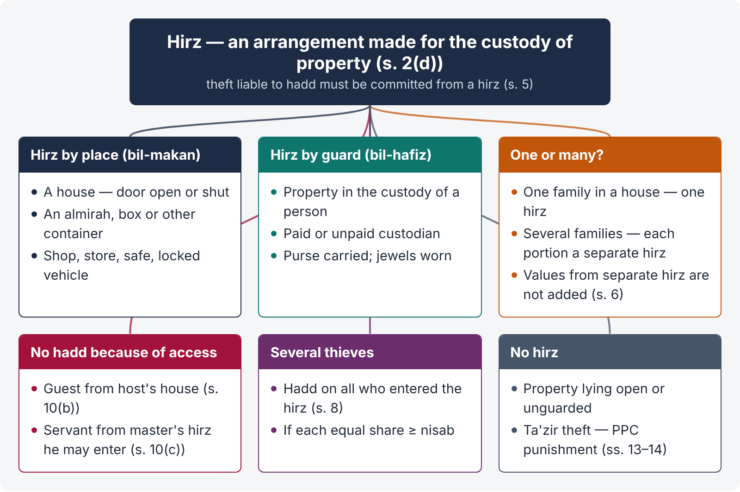
Figure 1 · Hirz — the custody that turns theft into hadd theft

Meaning
Hirz (literally "a safe or protected place") is "an arrangement made for the custody of property" (s. 2(d)). In Islamic law, the hand is cut only for taking property out of protection — a person who leaves property unguarded has himself exposed it, and the taker's act, though theft, lacks the gravity that justifies the fixed penalty. Hirz is therefore an essential ingredient of theft liable to hadd (s. 5: "commits, from any hirz, theft …").

What is hirz — Explanation 1
"Property placed (a) in a house, whether its door is closed or not, or (b) in an almirah or a box or other container, or (c) in the custody of a person, whether he is paid for such custody or not, is said to be in hirz."
So the Ordinance recognises the two classical kinds:
Kind | Meaning and examples
Hirz bil-makan (by place) | A place meant for keeping property — a house (door open or shut), shop, store, almirah, safe, trunk, box, locked vehicle
Hirz bil-hafiz (by guard) | Property in the custody of a person — a watchman, a shopkeeper sitting with his goods, a person carrying his purse or wearing his jewellery, a guard over cattle — paid or unpaid

One hirz or many — Explanation 2
"If a single family is living in a house, the entire house will constitute a single hirz; but if two or more families are living in one house severally, the portion in the occupation of each family will constitute a separate hirz." This matters for the nisab — value taken from different rooms of one family's house is added together; from two families' portions, it is not (s. 6, illus. (a)).

Consequences of the hirz requirement
- No hirz — no hadd: taking property lying openly in a public place or an unguarded field is theft liable only to ta'zir (s. 13), punished under the PPC (s. 14).
- Access to the hirz excludes hadd: a guest stealing from his host's house (s. 10(b)), a servant or employee stealing from the hirz of his master to which he is allowed access (s. 10(c)) — the property was not "protected" against him.
- Each hirz is separate — several thefts from one hirz, each below nisab, are not added (s. 6, Explanation and illus. (b)).
- Entering the hirz — where several persons commit hadd theft, hadd is imposed on all who have entered the hirz, if each one's equal share reaches nisab, whether or not each moved the property (s. 8).
- Theft from the person (pick-pocketing, snatching) — the person is a hafiz; a surreptitious taking of nisab-value property from his custody may be hadd theft, but open snatching is not "surreptitious" and falls outside hadd (see s. 5, Explanation 2).

4.3 Theft liable to hadd — s. 5
"Whoever, being an adult, surreptitiously commits, from any hirz, theft of property of the value of the nisab or more, not being stolen property, knowing that it is or is likely to be of the value of the nisab or more is, subject to the provisions of this Ordinance, said to commit theft liable to hadd."

Ingredients
- Theft as defined in the PPC (s. 378) — dishonest taking of movable property out of another's possession without consent (s. 2(g));
- by an adult (18 years or puberty);
- surreptitiously — the thief believes the victim does not know of his action. Explanation 2: by day (which includes one hour before sunrise and two hours after sunset) the secrecy must continue till completion; by night, it need not continue after commencement;
- from a hirz;
- property of the value of nisab or more;
- not "stolen property" — taking from a thief is not hadd theft (but property criminally misappropriated or the subject of criminal breach of trust is not "stolen property" for this purpose — Explanation 1);
- knowledge that the value is or is likely to be nisab or more.

4.4 Nisab — s. 6
The nisab is 4.457 grams of gold (four decimal four five seven), or other property of equivalent value, at the time of the theft. Explanation: thefts in more than one transaction, or from more than one hirz, each below nisab, do not make hadd theft even if they add up to nisab.

4.5 Proof — s. 7 (KPHC 2026)
Proof of theft liable to hadd shall be in one of two forms:
- (a) the accused pleads guilty of the commission of theft liable to hadd; or
- (b) at least two Muslim adult male witnesses, other than the victim, about whom the court is satisfied, having regard to tazkiyah-al-shuhood, that they are truthful persons and abstain from major sins (kabair), give evidence as eye-witnesses of the occurrence.
Provisos: if the accused is non-Muslim, the eye-witnesses may be non-Muslims; the statement of the victim (or his authorised person) shall be recorded before the statements of the eye-witnesses.
If either form of proof is not available, the offence is theft liable to ta'zir (s. 13) and may be proved by ordinary evidence.

4.6 Several offenders — s. 8
Where hadd theft is committed by more than one person, and the aggregate value is such that, divided equally among those who entered the hirz, each share amounts to or exceeds nisab, hadd is imposed on all who entered the hirz, whether or not each moved the property.

4.7 Punishment — s. 9
- First hadd theft — amputation of the right hand from the joint of the wrist.
- Second — amputation of the left foot up to the ankle.
- Third or subsequent — imprisonment for life (till death); the appellate court may release him on terms if satisfied that he is sincerely penitent (s. 9(5)).

4.8 The process of implementation (KPHC 2026)
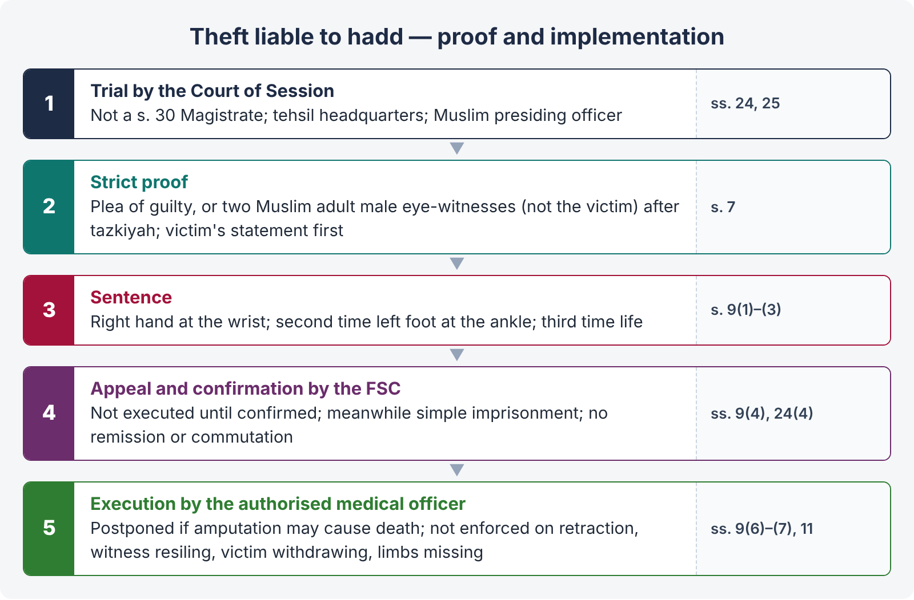
Figure 2 · Theft liable to hadd — from complaint to execution
- Trial by a Court of Session (not a s. 30 Magistrate), ordinarily at the tehsil headquarters; presiding officer a Muslim (ss. 24, 25).
- Proof strictly under s. 7 — plea of guilty, or two qualified eye-witnesses after tazkiyah; victim's statement first.
- Sentence of amputation under s. 9.
- Appeal and confirmation — the punishment shall not be executed unless it is confirmed by the court to which an appeal lies — the Federal Shariat Court (s. 9(4); s. 24 proviso); until confirmed and executed, the convict is treated as in simple imprisonment.
- No remission or commutation — Chapter XXIX CrPC (suspension, remission, commutation of sentences) does not apply to punishments under ss. 9 and 17 (s. 24(4)).
- Execution by an authorised medical officer (s. 9(6)) — if he is of the opinion that amputation may cause death, execution is postponed until the apprehension ceases (s. 9(7)).
- Cases where hadd is not enforced (s. 11) — retraction of the confession; a witness resiling so that fewer than two remain; the victim withdrawing the allegation or saying the confession or evidence was false; or the offender's left hand, left thumb, two fingers of the left hand, or right foot being missing or unserviceable — then retrial (after retraction) or ta'zir on the evidence (s. 11(2), (3)).
- Return of property (s. 12) — the stolen property, or what it was converted into, is returned to the victim from whoever holds it; if lost or consumed while with the offender and hadd is enforced, the offender pays no compensation.
- In practice — owing to the strict proof required and the doctrine of doubt, sentences of amputation have rarely been passed and none is reported to have been executed; theft cases are decided as ta'zir under the PPC.

4.9 Cases in which hadd shall not be imposed — s. 10
- (a) offender and victim are related as spouses; ascendants or descendants (paternal or maternal); paternal or maternal uncles and aunts; brothers or sisters or their children;
- (b) a guest steals from the house of his host;
- (c) a servant or employee steals from the hirz of his master to which he is allowed access;
- (d) the property is wild grass, fish, bird, dog, pig, intoxicant, musical instrument, or perishable foodstuff for whose preservation there is no provision;
- (e) the offender has a share in the property and, after deducting it, the value is below nisab;
- (f) a creditor steals his debtor's property and, after deducting the debt, the value is below nisab;
- (g) theft under ikrah (putting a person in fear of injury to the person, property or honour of himself or another) or iztirar (apprehension of death from extreme hunger or thirst);
- (h) the offender, before apprehension, out of repentance, returns the property and surrenders to the authorities.

4.10 Theft liable to ta'zir — ss. 13, 14
Theft which is not liable to hadd, or for which s. 7 proof is not available, or for which hadd may not be imposed or enforced, is liable to ta'zir — the punishment provided for theft in the PPC (ss. 379–382).

4.11 Haraabah — ss. 15 to 20
- Definition (s. 15) — when one or more persons, armed or not, make a show of force for the purpose of taking away the property of another and attack him or cause wrongful restraint or put him in fear of death or hurt (the Islamic counterpart of robbery and dacoity; Quran 5:33).
- Proof (s. 16) — as in s. 7.
- Punishment (s. 17) — (1) no murder and no property taken — whipping up to 30 stripes and rigorous imprisonment until sincerely penitent, not less than three years; (2) hurt caused, no property taken — in addition, punishment for the hurt; (3) property of nisab value taken, no murder — amputation of the right hand from the wrist and the left foot from the ankle (each offender's share must reach nisab; if the left hand or right foot is missing — RI up to 14 years and 30 stripes); (4) murder committed — death as hadd.
- Confirmation and execution — as for theft; ss. 10 and 11 apply (s. 18); return of property (s. 19).
- Ta'zir haraabah (s. 20) — where hadd is not attracted or not proved, the PPC punishment for dacoity, robbery or extortion.

4.12 Other provisions
- Rassagiri or patharidari (s. 21) — extending patronage, protection or harbour to cattle thieves in return for a share — RI up to 14 years, or whipping up to 70 stripes, confiscation of all immovable property and fine.
- Attempt (s. 22) — imprisonment up to 10 years.
- PPC provisions applied (s. 23) — ss. 34–38 (joint liability), 71–72 and 149; abetment of a hadd offence is punished as ta'zir.
- CrPC (s. 24) — applies; if the evidence shows a different offence under another law, the court may convict of it; trial by the Court of Session; appeal to the Federal Shariat Court for ss. 9 and 17 and for any sentence exceeding two years.
Point | Theft under the PPC (ss. 378–382) | Theft liable to hadd (Ordinance s. 5)
Age | Over 10 (PPC ss. 82–83) | Adult — 18 or puberty
Manner | Any taking without consent | Surreptitious
Place | Anywhere | From a hirz
Value | Any | Nisab — 4.457 g of gold
Proof | Ordinary evidence | Plea of guilty or two qualified Muslim male eye-witnesses
Punishment | Imprisonment up to 3, 7 or 10 years | Amputation; life on the third occasion
Court | Magistrate | Court of Session; appeal to the FSC

Chapter 5 · The Prohibition (Enforcement of Hadd) Order 1979

5.1 Definitions — Art. 2
Adult — 18 or puberty; intoxicant — an article in the Schedule, including intoxicating liquor (toddy, spirits, beer and all liquids containing alcohol normally used for intoxication — not solid intoxicants even if liquefied); public place — a street, park, or a place to which the public has access, including a hotel, restaurant, club, but not the residential room of a hotel occupied by a person; Prohibition Officer, manufacture, sale (any transfer, including a gift).

5.2 Offences and punishments
Art. 3(1) | Import, export, transport, manufacture, process, bottle, sell or serve any intoxicant, or allow it on premises | Up to 5 years, 30 stripes, and fine
Art. 3(2) | The same, or financing, for opium, coca leaf or their derivatives | Life, or not less than 2 years, 30 stripes, fine
Art. 4 | Owning, possessing or keeping any intoxicant — not for a non-Muslim keeping a reasonable quantity for a religious ceremony | Up to 2 years, or 30 stripes, and fine; heroin or cocaine over 10 g, opium or coca leaf over 1 kg — life or not less than 2 years
Art. 8 | Drinking liable to hadd — an adult Muslim taking intoxicating liquor by mouth | 80 stripes (after confirmation by the appellate court)
Art. 11 | Drinking liable to ta'zir — (a) a Muslim whose drinking is not liable to hadd or not proved by Art. 9 evidence; (b) a non-Muslim citizen drinking except as part of a religious ceremony; (c) a non-Muslim foreigner drinking at a public place | Up to 3 years, or 30 stripes, or both
Art. 12(2) | Police officer detaining or arresting on suspicion of drinking without first offering a medical examination | Up to 6 months or fine Rs. 500
Art. 20 | Breach of licence conditions | Life or not less than 2 years and fine

5.3 Drinking, proof and arrest
- Drinking (Art. 6) — intentionally, and without ikrah or iztirar, taking an intoxicant by any means, whether or not it intoxicates. Ikrah — fear of injury to person, property or honour; iztirar — apprehension of death from extreme hunger, thirst or serious illness.
- Two kinds (Art. 7) — liable to hadd or to ta'zir.
- Proof of hadd (Art. 9) — confession before a competent court, or at least two Muslim adult male witnesses of integrity (tazkiyah-al-shuhood).
- Hadd not enforced (Art. 10) — on retraction, or a witness resiling so that fewer than two remain; the court may order a retrial.
- Arrest (Art. 12) — no police officer shall detain or arrest a person on suspicion of drinking unless he has asked him to accompany him to an authorised medical officer and he refuses, or is certified to have taken an intoxicant.
- Confiscation (Arts. 14–15) — the intoxicant, apparatus, receptacles, animals and vehicles used; even on acquittal; where the offender is unknown, by the Collector after 15 days' notice.
- Cognizance (Art. 16) — Art. 3 offences, and Arts. 4, 8, 11 at a public place, are cognizable.
- Licences (Art. 17) — for bona fide medicinal, scientific, industrial purposes, for non-Muslims' religious ceremonies and foreigners, and for export.
- Repeat offence (Art. 24), attempt (Art. 25) — half the longest term (two years RI for Art. 8); PPC ss. 34–38, 63–72 and Chapters V and V-A apply (Art. 26).
- Narcotics are now chiefly dealt with under the Control of Narcotic Substances Act 1997.

Chapter 6 · The Execution of the Punishment of Whipping Ordinance 1979
- Application (s. 1(3)) — to whipping imposed under any law (today, the Hudood laws); it overrides other laws (s. 3).
- The whip (s. 4) — a single piece, preferably of leather, a cane or a branch of a tree, with no knob or joint, not exceeding 1.22 metres in length and 1.25 cm in thickness (excluding the handle).
Conditions and mode of execution (s. 5):
Cl. | Condition
(a) | Medical examination first, to ensure the punishment will not cause death
(b) | If the convict is too old or weak, the stripes are applied in a manner and at intervals that do not cause death
(c) | An ill convict — postponed until certified fit
(d) | A pregnant woman — postponed until two months after the birth of the child or miscarriage
(e) | Weather too hot or too cold — postponed until normal
(f) | Executed in the presence of the authorised medical officer at a public place appointed by the Provincial Government
(g) | The executioner must be impartial and of mature understanding
(h) | moderate force, without raising his hand above his head, so as not to lacerate the skin
(i) | After each stripe, the whip is raised aloft, not pulled off
(j) | Stripes spread over the body, not on the head, face, stomach, chest or delicate parts
(k) | The convict keeps the clothes required by the Injunctions of Islam
(l) | A male standing, a female sitting
(m) | If, during execution, the medical officer apprehends death, the rest is postponed

Custody (s. 6) — a convict sentenced only to whipping is treated as in simple imprisonment until execution; if he cannot undergo whipping (old age, ill-health), the case is referred to the court, which may order execution in such manner as it thinks fit.

Chapter 7 · Comparisons, maxims and last-night revision

7.1 The five hadd offences side by side
Offence | Law | Proof | Hadd | Not enforced if
Zina | Zina Ord. ss. 5, 8 | Confession before Sessions Court, or 4 Muslim male eye-witnesses of penetration | Stoning (muhsan); 100 stripes | Retraction; witnesses fall below 4
Qazf | Qazf Ord. ss. 5–7 | Confession; qazf in court's presence; 2 witnesses | 80 stripes; evidence inadmissible | Complainant withdraws; true imputation
Theft | Property Ord. ss. 5–9 | Plea of guilty, or 2 Muslim male eye-witnesses (not the victim) | Right hand; left foot; life | Retraction; witnesses below 2; victim withdraws; limbs missing
Haraabah | Property Ord. ss. 15–17 | As for theft | Whipping + RI; hand and foot; death | As for theft
Drinking | Prohibition Order Arts. 8–9 | Confession, or 2 Muslim male witnesses | 80 stripes | Retraction; witnesses below 2

7.2 Ikrah, iztirar and the PPC's ikrah
Term | Hudood laws | PPC (Chapter XVI)
Ikrah | Putting a person in fear of injury to person, property or honour of himself or another — excludes hadd for theft (s. 10(g)) and drinking (Art. 6) | Ikrah-e-tam — fear of instant death, permanent impairment of an organ, sodomy or zina-bil-jabr; ikrah-e-naqis — lesser duress (s. 299(g), (h); s. 303)
Iztirar | Apprehension of death from extreme hunger or thirst (and, in the Prohibition Order, serious illness) — necessity | No equivalent term — necessity under s. 81 PPC

7.3 Maxims
Maxim | Meaning | Where it applies
Idra'u al-hudood bi al-shubuhat | Avert the hudood by doubts | All hadd offences — failure of strict proof leads to ta'zir
Al-bayyinatu ala al-mudda'i wal-yaminu ala man ankar | Proof on the claimant, oath on the denier | Burden on the complainant; lian
La hadda illa bi nass | No hadd without a text | Hadd only where the Quran or Sunnah prescribes it
Tawbah (repentance) before apprehension | Repentance with return of property | s. 10(h) Property Ordinance; haraabah (Quran 5:34)

7.4 The 25 points of Topic 4
QUICK RECAP · Revision sheet
- Hadd — fixed by Quran / Sunnah; ta'zir — any other punishment; doubt averts hadd.
- Tazkiyah-al-shuhood — court's inquiry into witnesses' truthfulness and abstention from major sins.
- Five laws of 10 February 1979 — Ordinances VI (property), VII (zina), VIII (qazf), IX (whipping), P.O. 4 (prohibition).
- 2006 Act — rape to PPC; fornication s. 496B; complaint-only (CrPC ss. 203A, 203C); no conversion (s. 5A); s. 156B; qazf on failed complaint.
- Adult — male 18, female 16 or puberty (Zina Ord.); 18 or puberty (Property Ord., Prohibition Order).
- Muhsan (zina) — Muslim, adult, sane, has had intercourse within a valid marriage.
- Zina (s. 4); hadd zina (s. 5) — stoning if muhsan, 100 stripes otherwise; FSC confirmation.
- Proof (s. 8) — confession before the Sessions Court, or four Muslim adult male eye-witnesses of penetration.
- s. 9 — retraction; witnesses below four; s. 17 — stoning by witnesses; may be shot.
- Sessions Court at tehsil headquarters; appeal to FSC; Muslim presiding officer.
- Qazf (s. 3) — imputation of zina to harm reputation or hurt feelings; deceased; ironical; two exceptions.
- Hadd qazf (s. 5) — adult, intentional, unambiguous, against a muhsan capable of intercourse; calling a person illegitimate = qazf of his mother.
- Proof (s. 6) — confession; in court's presence; two witnesses; s. 6(2) — failed zina complaint.
- 80 stripes + evidence inadmissible (s. 7); complaint by the victim or his ascendants / descendants (s. 8); not against descendants; truth (s. 9).
- Lian (s. 14) — four oaths and a curse each; dissolution, no appeal; DMMA s. 2(viia).
- Hirz — arrangement for custody; house (door open or shut), almirah, box, container, custody of a person (paid or not); one family = one hirz.
- Hadd theft (s. 5) — adult, surreptitious (day / night rule), from hirz, nisab, not stolen property, knowledge of value.
- Nisab — 4.457 g of gold at the time of theft; no aggregation across transactions or hirz.
- Proof (s. 7) — plea of guilty, or two Muslim adult male eye-witnesses other than the victim; victim's statement first.
- Punishment (s. 9) — right hand at wrist; left foot at ankle; life (till death); FSC confirmation; medical officer; postponement if death feared; no Chapter XXIX remission.
- No hadd (s. 10) — close relatives, guest, servant with access, trivial or forbidden things, share, creditor, ikrah / iztirar, repentance with return.
- Not enforced (s. 11) — retraction, witnesses below two, victim withdraws, limbs missing; ta'zir under PPC (ss. 13–14).
- Haraabah (ss. 15–20) — show of force to take property; 30 stripes + 3 years RI; hand and foot; death if murder; ta'zir — PPC dacoity / robbery / extortion.
- Prohibition — Art. 3 (5 years + 30 stripes), Art. 4 (possession), Art. 8 (adult Muslim by mouth — 80 stripes), Art. 9 (confession or two witnesses), Art. 11 (ta'zir — 3 years / 30 stripes), Art. 12 (medical examination before arrest).
- Whipping — whip ≤ 1.22 m × 1.25 cm; medical examination; pregnant — two months after birth; not on head, face, stomach, chest; male standing, female sitting.

